**CURRICULUM VITAE OF**

**MD. NAHIDUL ISLAM**

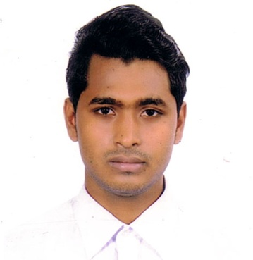

**Mailing Address:**

House No:16, Road No:23, Avenue-5,

Mirpur-11, Dhaka-1216

Cell No: 01636-696632

E-mail : [nahidahammed45@outlook.com](mailto:naheed.shimul@gmail.com)

**OBJECTIVES:**

|  |
| --- |
| blank |

Looking for such a position in which I can deliberate my academic learning and professional experience with my commitment and creativity with sincerity to achieve the optimum output of the institution.

**ACADEMIC QUALIFICATION:**

|  |
| --- |
| blank |

**Higher Secondary School Certificate(H.S.C)**

Institute : Turag Management College.

Subject : BM

Result : GPA- 4.42

Passing Year : 2019

Board : BTEB

**Secondary School Certificate (Dakhil):**

Institute : Fatehpur J.U Fazil Madrasah

Subject : General

Result : GPA- 3.90

Passing Year : 2017

Board : Madrasah

**LANGUAGE PROFICIENCY:**

|  |
| --- |
|  |

|  |  |  |  |  |
| --- | --- | --- | --- | --- |
| **Language** | **Speaking** | **Reading** | **Writing** | **Listening** |
| Bangla | Native | Native | Native | Native |
| English | Good | Good | Good | Good |

**Interest:**

|  |
| --- |
|  |

Music, Sports, Writing, Traveling, Social Activities, Watching TV, , Reading Book & Magazines.

**EXPERIENCE:**

|  |
| --- |
|  |

* Office Program (Ms- Word, Ms-Excel ,Ms- Access, Ms-Power point).
* Internet Browsing, E-mail etc.
* Graphic Designer.
* Clipping Path Services.
* Changing Background.
* Resizing Images.
* Transparent & White background.
* Remove background.
* Image Tracing.
* Business Card design.
* LOGO Design.
* Flyers & posters.

**CAPABILITIES:**

|  |
| --- |
|  |

* Energetic and agile in nature.
* Able to work in challenging condition and long hours.
* Willing to work in a team.
* Organized and self-motivated.
* Will be comfort in working under pressure.
* Always determined to reach the target.

**PERSONAL INFORMATION:**

|  |
| --- |
| blank |

|  |  |  |  |  |
| --- | --- | --- | --- | --- |
| Full Name | Md. Nahidul Islam |  | Date Of Birth | 05 May 2000 |

|  |  |  |  |  |
| --- | --- | --- | --- | --- |
| Father’s Name | Md. Shajahan |  | Sex | Male |

|  |  |  |  |  |
| --- | --- | --- | --- | --- |
| Mother’s Name | Nuren Nehar Begum |  | Home District | Laxmipur |

|  |  |  |  |  |
| --- | --- | --- | --- | --- |
| Present  Address | House No:16,  Road No:23, Avenue-5,  Mirpur-11, Dhaka-1216 |  | Permanent Address | Vill: South Daspara,  P.O: Daspara,  P.S: Ramgonj,  Dist: Laxmipur, |

|  |  |  |  |  |
| --- | --- | --- | --- | --- |
| Mobile No. | +8801636-696632 |  | Blood Group | O+ |

|  |  |  |  |  |
| --- | --- | --- | --- | --- |
| Nationality | Bangladeshi (By Birth) |  | Marital status | Unmarried |

|  |  |
| --- | --- |
| Religion | Islam |

**DECLARATION:**

|  |
| --- |
|  |

Hereby I declare that, all information Finished in these curriculum vitae are correct and complete.

**Signature**

...........................................................

**(**Nahidul Islam**)**